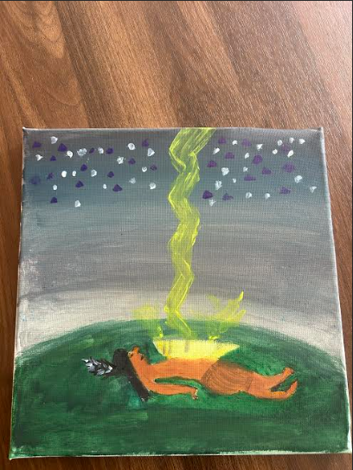
I have used this website to give me all of my information about my painting(glooscap.) my painting demenstarits glooscap on his back while being struck by lightning. I also wanted to add some nice effects so I have put some blue and white dots to make it pop out more. I have learned from this website was that I did not know was that he stayed on his back for 365 days and nights then his grandmother was born as a old women from the dew of the dock.

